**Task # 2 Description**

**Question # 1:**

This is a **FizzBuzz program** that prints numbers from 1 to 100, but with special rules:

1. **Loop (for i in range(1, 101)):**  
   Iterates through all numbers from 1 to 100 one by one.
2. **Condition – Divisible by 3 and 5 (i % 3 == 0 and i % 5 == 0):**  
   If a number is divisible by both 3 and 5, it prints "FizzBuzz".  
   Example: 15, 30, 45 …
3. **Condition – Divisible by 3 (i % 3 == 0):**  
   If a number is divisible only by 3, it prints "Fizz".  
   Example: 3, 6, 9 …
4. **Condition – Divisible by 5 (i % 5 == 0):**  
   If a number is divisible only by 5, it prints "Buzz".  
   Example: 5, 10, 20 …
5. **Else Condition:**  
   If the number is not divisible by either 3 or 5, it simply prints the number itself.  
   Example: 1, 2, 4, 7 …

**Output Screen shots:**

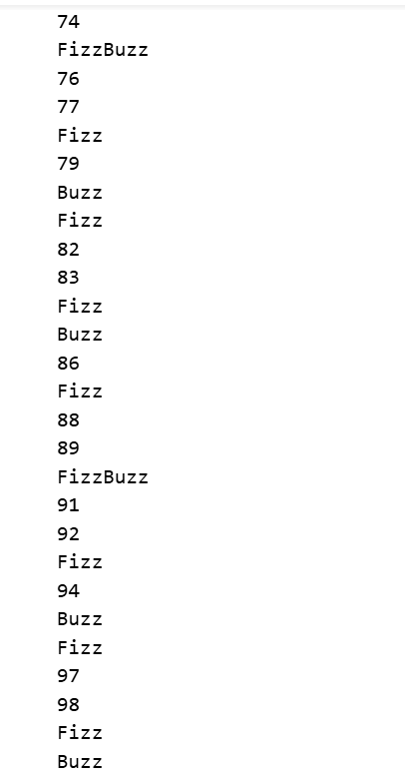

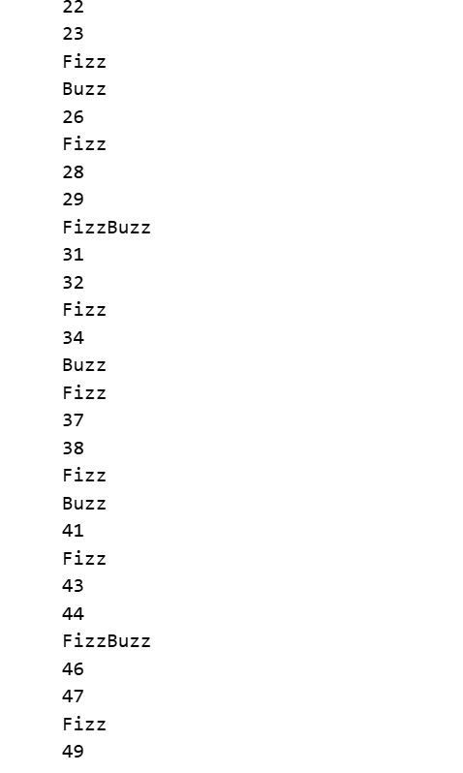

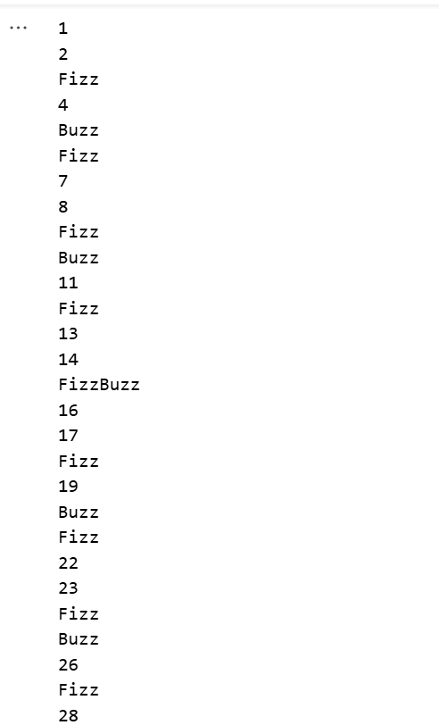

**Question # 2:**

This Python script manages a list of films with their budgets, allows adding more films, calculates the average budget, and highlights which films are above average

**Initial Film List**: A predefined list (film_list) contains tuples of film titles and their budgets.

**Adding Films**: The user is asked how many extra films they want to add. For each one, the script takes the film title and budget, then appends it to the list.

**Average Budget Calculation**: It sums all the budgets using a generator expression and divides by the number of films to get the average.

**Above Average Check**: The program iterates through the films. If a film’s budget is greater than the average, it prints the title with the difference (how much above the average) and counts it.

**Final Count**: After listing, it prints the total number of films whose budget is above the calculated average

**Output Screen shots:**

